ˆ_ ProjectInformation DAAssignment-2

**TeamID:**  LTVIP2025TMID60948

**TeamLeader:**Satya Venkat Musudi

**Teammember:**Sireesha Tandala

**Teammember:**Sneha Deepthi Sri Alluri

**Teammember:**Sri Harsha Kodela

**INSTITUTION: swarnandhra college of engineering and technology**

**ProjectTitle:***MeasuringthePulseofProsperity:AnIndexofEconomicFreedomAnalysis*

⬛]¡#**VisualizationScreenshots**

* **DonutChart–Branch-wiseSalesContribution**

**Caption:thisismadebymeasgiftype…**

Thisdonutchartdisplaysthetotalsalescontributionfromeachbranch(A,B,C).Thecenterhighlights the overall sales volume while the segments show the proportional share by branch.

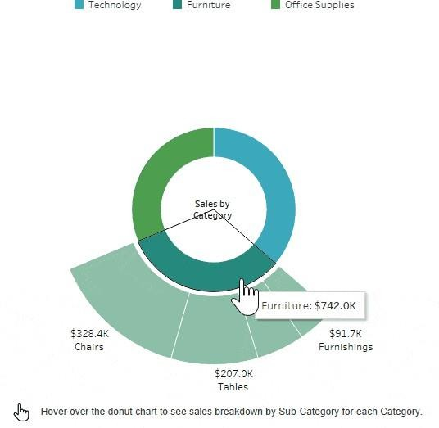

⬛2**Area Chart – MonthlySales Trend Caption:**

Thisareachartvisualizesthetotalsalesoverthethreemonths(JanuarytoMarch2019).Itusescolor

shadingtoshowbranch-levelcontributi

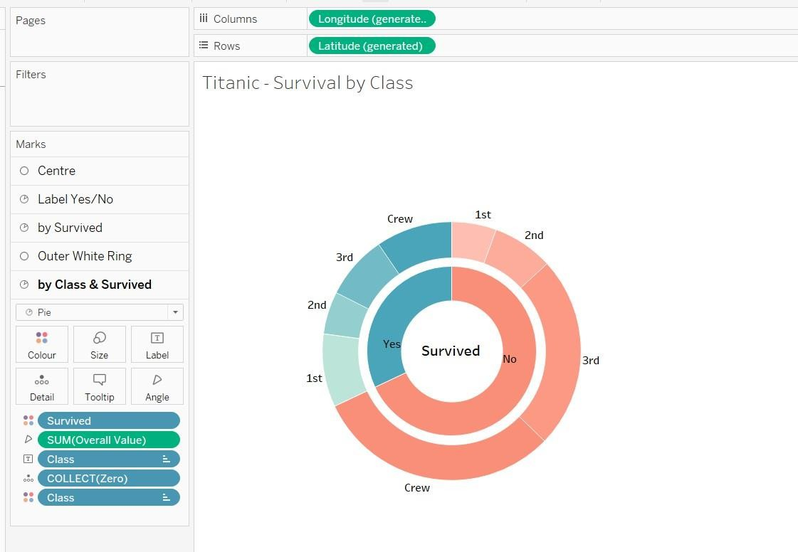onacrosstime.

⬛3**TextTable– ProductLineSalesSummary Caption: converted into gif by me…**

Thistexttableprovidesadetailedbreakdownofsales,quantitysold,grossincome,andaverage customer rating per product line and customer type.

.

* **WordCloud–MostPurchasedProductLines**

**Caption:**

Thiswordcloudillustratesthepopularityofdifferentproductlinesbasedonthenumberofitems purchased. Font size reflects quantity sold.

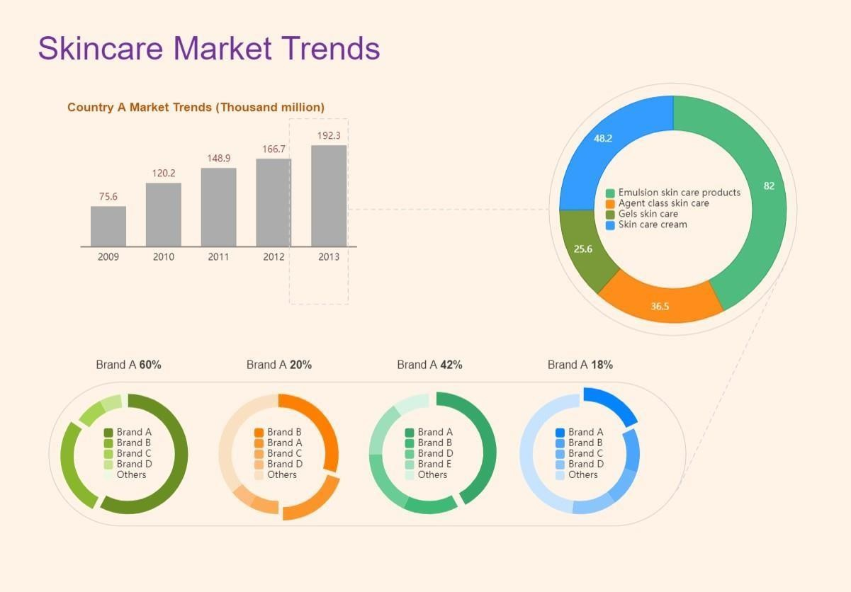

⬛6**FunnelChart–PaymentMethodUsage Caption:**

Thisfunnelchartvisualizesthevolumeofsalesthrougheachpaymentmethod.Itnarrowsfromthe most to least used method.